**Web Application Security Retesting Audit Report**

**of**

**Department of FCSCA.**

**Website:** [**https://aqcsindia.gov.in**](https://iaos.cga.gov.in)

**Submitted By**

**Secnic Consultancy**

|  |  |
| --- | --- |
| Report Release Date | 25.07.2025 |
| Type of Audit | Application Security Aduit |
| Type of Audit Report | Level 1 Report |
| Period | July 29, 2025 to AUG 1, 2025 |

© 2025 Department of FCSCA.

All rights reserved. All information contained in this document is confidential and proprietary to Department of FCSCA. No part of this document may be photocopied, electronically transferred, modified, or reproduced in any manner without the prior written consent of Department of FCSCA.

All brands or product names are trademarks or registered trademarks of their respective companies or organisations.

**Document Control**

|  |  |
| --- | --- |
| **Document Preparations** | |
| **Document Title** | Application Security Retesting Audit Report |
| **Document ID** | SCS/WAC/202503 |
| **Document Version** | 1.0 |
| **Prepared By** |  |
| **Reviewed By** |  |
| **Approved By** |  |
| **Released By** |  |
| **Released Date** | 29 July 2025 |
| **Retesting Date** | 19 Aug 2025 |

**Document Change History**

|  |  |  |
| --- | --- | --- |
| Version | Date | Remarks |
| 1.0 | July 29, 2025 | Level 1 report |

**Document Distribution List**

|  |  |  |  |
| --- | --- | --- | --- |
| Name | Organization | Designation | Email Id |
| Atul Suri | Manager (Quality & Audit) | Department of FCSCA |  |

**Table of Contents**

1. EXECUTIVE SUMMARY 3

1.1 Introduction 3

1.2 Scope 3

1.3 Summary of Findings 4

1.4 Overall Assessment 4

1.5 Key Vulnerabilities Discovered 5

2. OVERALL SUMMARY OF FINDINGS 6

3. BENCHMARKING WITH OWASP 6

4. KEY FINDINGS AND ACTION ITEMS 8

5. General Guidelines 16

EXECUTIVE SUMMARY

This Report contains the results of Retesting performed on the patched application. Previously identified vulnerabilities were verified to confirm if they are fixed or still exploitable.

## Introduction

This report presents the results of the penetration testing for the Department of FCSCA. Website ([https://aqcsindia.gov.in](https://iaos.cga.gov.in)) The objective of the test was to find out vulnerabilities that can be seen and compromised by malicious users from the Internet. The application was found to be vulnerable to security risks including Security Misconfiguration, & Denial of Service issues etc... The following sections provide details of the scope of the penetration test, the IPs on which detailed penetration testing was conducted, and the detailed findings from the penetration testing exercise.

Our opinion provided in this report is valid for the period during which the penetration testing was carried out and is based on the information and the website contents provided for audit. Projection of any conclusions based on our findings for future periods and application versions is subject to the risk that the validity of such conclusions may be altered because of changes made to the network or application or system or the failure to make the changes to the network, application, system when required.

## Disclaimers and Restrictions

* Organization’s management is responsible for its assertions. Our responsibility is to express an opinion on management’s assertion based on our audit.
* The audit was conducted in accordance with the Information Systems Auditing Standards issued by the Standards Board of Information Systems Audit and Control Association. Further, the objective of the audit was to obtain reasonable assurance that the assertion is not materially misstated. Our audit included
  1. Obtaining an understanding of the objectives;
  2. selectively testing these objectives;
  3. testing and evaluating; and
  4. performing such other procedures as we considered necessary under the circumstances. We believe that our audit provides a reasonable basis for our opinion.
* Because of inherent limitations in controls, errors or fraud may occur and may not be detected. Furthermore, the projection of any conclusions, based on our findings, to future periods are subject to the risk that changes made to the system or controls, changes in processing requirements, changes required because of the passage of time, or degree of compliance with the policies or procedures may alter the validity of such conclusions.
* This report is strictly to be used for the intend purpose of compiling the controls being followed for the purposes of analysis and improvement.
* It is firmly recommended to test out all our technical recommendations to the system internals such as services or registry in a test environment and the impact on the reliability and integrity of the system be evaluated before rolling out the changes to the production environment.
* This report does not include any representation on the financial, marketing, human resources or any other health of the Organization or on the future viability of the Organization or minimizing or exposure of all risks associated with computerized environment, due to its inherent limitations.

## Details of the Auditing Team

|  |  |  |  |  |  |
| --- | --- | --- | --- | --- | --- |
| **Sr. No.** | **Name** | **Designation** | **Email Id** | **Professional Qualifications/ Certifications** | **Whether the resource has been shortlisted in the snapshot information published on Cert-In’s website (Yes/No)** |
| 1 |  |  |  | CISA, ISO 27001 LA | Yes |
| 2 |  |  |  | ISO LA | Yes |
| 3 |  |  |  | CEH | Yes |

## Audit Activities and Timelines

|  |  |
| --- | --- |
| ***Audit Phases*** | ***Timelines*** |
| **Receipt of URL/Application Auditee for Audit** | **July 29, 2025** |
| **Execution of Assignment** |  |
| **Report Preparation** |  |
| **Report Submission to Auditee** | **AUG 01, 2025** |
| **Retesting Report** | **AUG 19, 2025** |
| **Retesting Report** | **AUG 23, 2025** |

## Audit Methodology and Criteria / Standard referred for audit

During the course of this review, we assessed the activities as stated above for compliance with OWASP & other known vulnerabilities and best practices, as applicable. We conducted the assignment using automated tools and conducting manual testing, as applicable.

## Tools/Software Used

|  |  |  |  |
| --- | --- | --- | --- |
| **Sr. No.** | **Name of Tool/Software Used** | **Version of the tool/Software used** | **Open Source/Licensed** |
| 1. | Burp Suite Professional | 2024.5 | Licensed |
| 2. | Invicti Standard | 25.5.1 | Licensed |
| 3. | Kali Tools |  | Open Source |
| 4. | Manual scripts |  |  |
| 5. | Browser | Latest | Open |
| 6. | Owasp Zap | 2.16.1 | Open |

## Scope

The following table details an overview on the scope of the penetration test.

|  |  |
| --- | --- |
| ***Details*** | |
| **Application Name** | **AQCSINDIA** |
| **Testing IP/URL** | [**https://aqcsindia.gov.in**](https://iaos.cga.gov.in) |
| **Mode of Test** | **Grey Box Testing** |

## Summary of Findings

Penetration testing on the Website ([https://aqcsindia.gov.in](https://bharatkosh.gov.in/)) was performed for a period of 3 days. As a result of the penetration test following risks were identified:

|  |  |  |  |  |  |
| --- | --- | --- | --- | --- | --- |
| ***No of Findings*** | ***Critical*** | ***High*** | ***Medium*** | ***Low*** | ***Informational*** |
| **13** | **0** | **0** | **6** | **4** | **3** |

The table below gives an overall result of the findings from the penetration testing exercise. The “Key Findings and Action Items” section gives the details of the vulnerabilities and provides the recommendations to mitigate them.

## Overall Assessment

We identified 13 vulnerabilities during the penetration testing of the ([https://aqcsindia.gov.in](https://iaos.cga.gov.in)) After Retesting I Found only 1 vulnerability Patched by Owner The team concluded the risks based on the results of the various tests carried out during the penetration testing process. The following table lists down the key vulnerabilities discovered.

## 

## Key Vulnerabilities Discovered

|  |  |  |  |
| --- | --- | --- | --- |
| **Sr. No.** | **VULNERABILITY** | **RISK LEVEL** | **REMARKS &**  **ACTION ITEMS** |
| **1.** | **X-Content-Type-Options header is not set** | **Medium** | **Add the X-Content-Type-Options header in the web server or application configuration:**  **X-Content-Type-Options: nosniff** |
| **2.** | **Allow HTTP Methods: GET** | **Medium** | **Use a vetted library or framework that does not allow this weakness to occur or provides constructs that make this weakness easier to avoid.**  **For example, use anti-CSRF packages such as the OWASP CSRF Guard.** |
| **3.** | **CSP: Failure to Define Directive with No Fallback** | **Medium** | **Ensure that your web server, application server, load balancer, etc. is properly**  **configured to set the Content-Security-Policy header.** |
| **4.** | **CSP: script-src unsafe-eval** | **Medium** | **Ensure that your web server, application server, load balancer, etc. is properly configured to set the Content-Security-Policy header.** |
| **5.** | **CSP: script-src unsafe-inline** | **Medium** | **Ensure that your web server, application server, load balancer, etc. is properly configured to set the Content-Security-Policy header.** |
| **6.** | **CSP: style-src unsafe-inline** | **Medium** | **Ensure that your web server, application server, load balancer, etc. is properly configured to set the Content-Security-**  **Policy header.** |
| **7.** | **Server Leaks Version Information via "Server" HTTP Response Header Field** | **Low** | **Ensure that your web server, application server, load balancer, etc. is configured to suppress**  **the "Server" header or provide generic details.** |
| **8.** | **Strict-Transport-Security Header Not Set** | **Low** | **Ensure that your web server, application server, load balancer, etc. is configured to enforce Strict-Transport-Security.** |
| **9.** | **Timestamp Disclosure - Unix** | **Low** | **Manually confirm that the timestamp data is not sensitive, and that the data cannot be aggregated to**  **disclose exploitable patterns.** |
| **10.** | **X-Content-Type-Options Header Missing** | **Low** | **Manually confirm that the timestamp data is not sensitive, and that the data cannot be aggregated to disclose**  **exploitable patterns.** |
| **11** | **Information Disclosure - Suspicious Comment** | **Informational** | **Remove all comments that return information that may help an attacker and fix any underlying problems they**  **refer to.** |
| **12.** | **Modern Web Application** | **Informational** | **This is an informational alert and so no changes are required.** |
| **13.** | **Re-examine Cache-control Directives** | **Informational** | **For secure content, ensure the cache-control HTTP header is set with "no-cache, no-store,**  **must-revalidate". If an asset should be cached consider setting the directives "public, max-age,**  **immutable.** |

OVERALL SUMMARY OF FINDINGS

Below Chart gives the overall summary of number of Vulnerabilities discovered with the Risk rating. Total of 13 vulnerabilities medium 6, Low 4 Informational 3 level Vulnerabilities were reported.

BENCHMARKING WITH OWASP

The below chart depicts the number of discovered vulnerabilities mapped to OWASP Testing Category.

OWASP has rated the Top Ten Vulnerabilities found in web applications worldwide. OWASP Top Ten Vulnerabilities details can be found at below link.

https://owasp.org/Top10/

The table shows the application vulnerability mapped with respect to the OWASP Top 10 - 2021 list.

|  |  |  |
| --- | --- | --- |
| **Sl. No** | **Vulnerabilities** | **Status** |
| **1** | Broken Access Control | **Protected** |
| **2** | Cryptographic Failure | **Protected** |
| **3** | Injection | **Protected** |
| **4** | Insecure Design | **Protected** |
| **5** | Security Misconfiguration | **Protected** |
| **6** | Vulnerable and Outdated Components | **Protected** |
| **7** | Identification and Authentication Failures | **Protected** |
| **8** | Software and Data Integrity Failures | **Protected** |
| **9** | Security Logging and Monitoring | **Protected** |
| **10** | Server-Side Request Forgery (SSRF) | **Protected** |

|  |  |
| --- | --- |
| Tools | Used |
| 1. Burp Suite | 0 |
| 1. Kali Linux | 2 |
| Browser | 0 |
| OWASP ZAP | 9 |
| Metasploit Framework | 2 |

KEY FINDINGS AND ACTION ITEMS

1. X-Content-Type-Options header is not set

|  |  |  |  |
| --- | --- | --- | --- |
| ***Brief Description*** | ***Risk Rating*** | ***Impact on Application*** | ***Probability of Attack*** |
| **The web server response is missing the X-Content-Type-Options HTTP security header. This header prevents browsers from MIME type sniffing the response. Without it, browsers may guess the content type of files, which could allow malicious content to be executed** | **Medium** | **Medium** | **Medium** |

**Impact:**

An attacker could trick the browser into interpreting the response with an incorrect MIME type

Malicious scripts (such as XSS) may be executed if MIME sniffing is enabled

Security controls could be bypassed, leading to a higher risk of exploitation.

**Affected items**

<https://aqcsindia.gov.in>

**Proof of Concept:**

**Before: -**

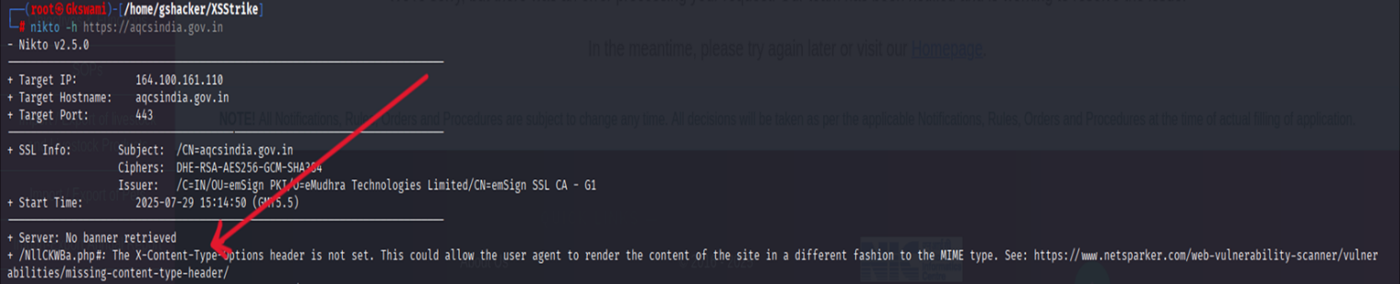

**After: -**

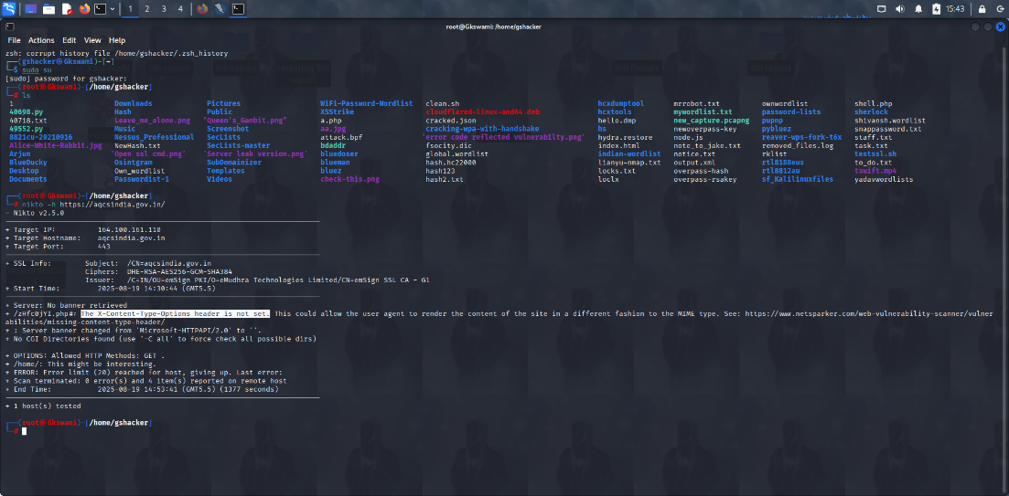

**Now:**

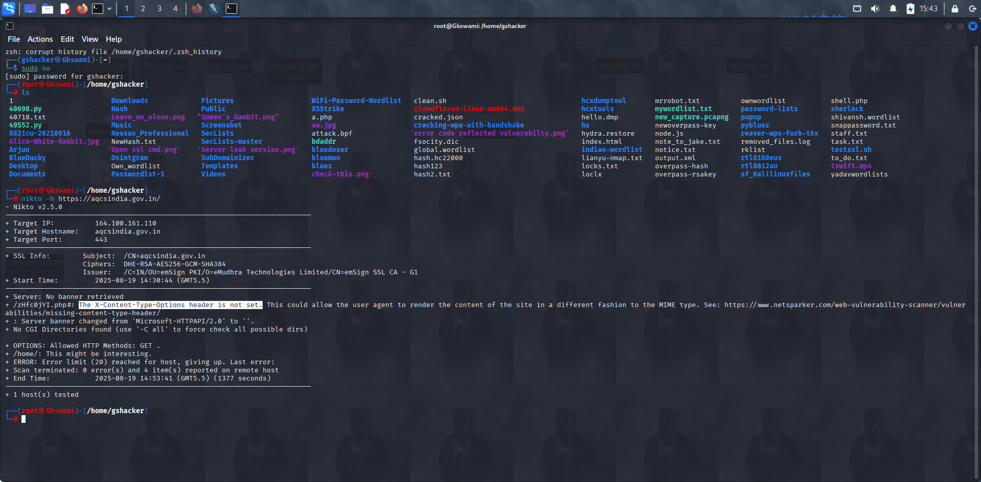

**Recommendation:**

Add the X-Content-Type-Options header in the web server or application configuration: X-Content-Type-Options: nosniff

Tool Used:- Nikto

Status:- Still Unpatched

1. Cross-Domain JavaScript Source File Inclusion

|  |  |  |  |
| --- | --- | --- | --- |
| ***Brief Description*** | ***Risk Rating*** | ***Impact on Application*** | ***Probability of Attack*** |
| **The page includes one or more script files from a third-party domain.** | **Low** | **Low** | **Medium** |

**Impact:**

An attacker could trick the browser into interpreting the response with an incorrect MIME type

Malicious scripts (such as XSS) may be executed if MIME sniffing is enabled

Security controls could be bypassed, leading to a higher risk of exploitation.

**Affected items**

<https://aqcsindia.gov.in/robots.txt>

**Proof of Concept:**

**<script src="https://translation plugin.bhashini.co.in/v3/website_translation_utility.js"></script>**

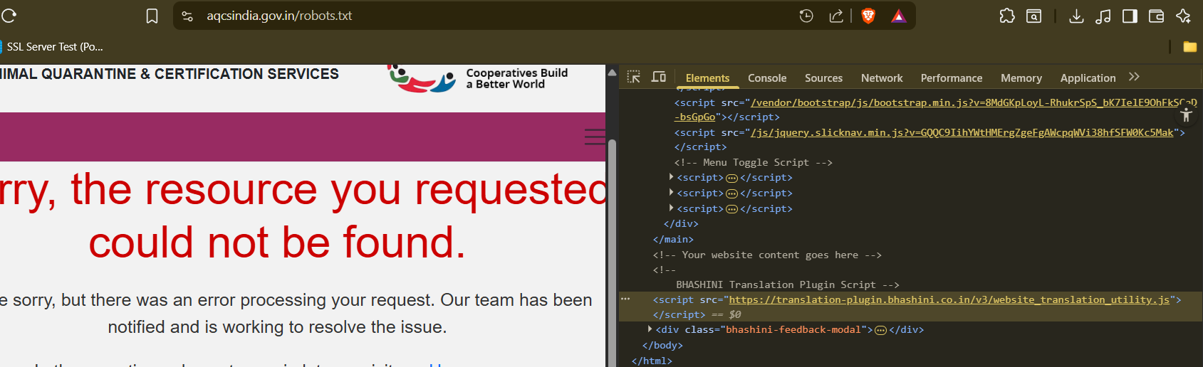



**Recommendation:**

Ensure JavaScript source files are loaded from only trusted sources, and the sources can't be controlled by end users of the application.

Tool Used:- Browser

1. CSP: Failure to Define Directive with No Fallback

|  |  |  |  |
| --- | --- | --- | --- |
| ***Brief Description*** | ***Risk Rating*** | ***Impact on Application*** | ***Probability of Attack*** |
| **The Content Security Policy fails to define one of the directives that has no fallback.**  **Missing/excluding them is the same as allowing anything.** | **Medium** | **medium** | **medium** |

**Impact:**

When a CSP directive like script-src or object-src is not explicitly defined and there's no default-src fallback, the browser may allow the execution or loading of potentially unsafe content. This increases the risk of:

* **Reflected and Stored XSS attacks**
* **Clickjacking**
* **Data exfiltration via malicious scripts**
* **Execution of untrusted third-party content**

Attackers may exploit these weaknesses to:

* Steal session tokens or sensitive information
* Deface the application
* Redirect users to malicious sites

**Affected items**

[**https://aqcsindia.gov.in/**](https://aqcsindia.gov.in/)

**Proof of Concept:**

**Before**

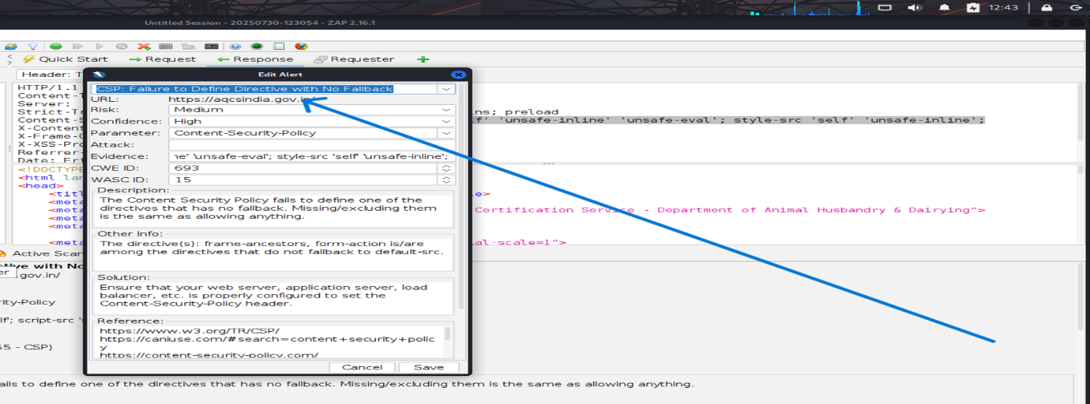

**After:-**

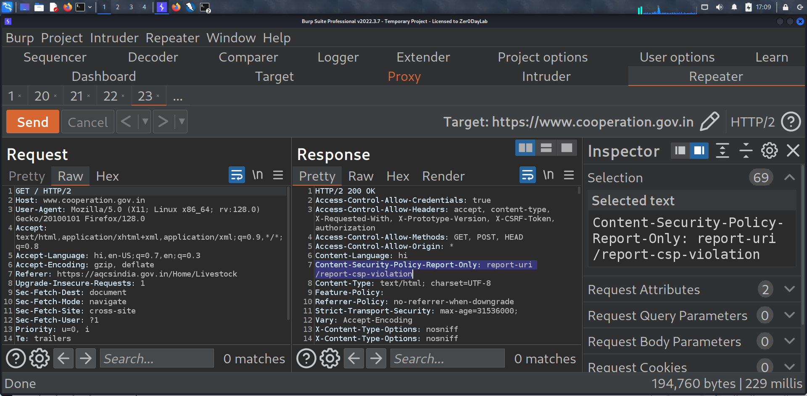

**Now:**

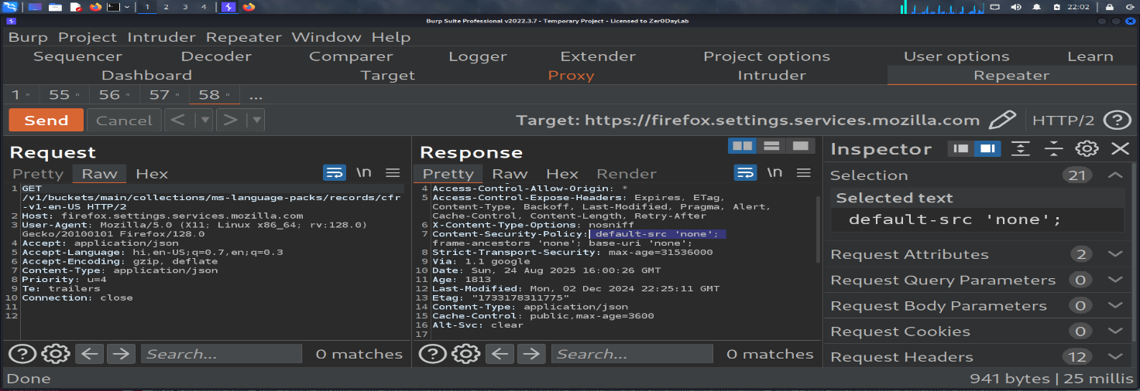

**Recommendation:**

Ensure that your web server, application server, load balancer, etc. is properly

configured to set the Content-Security-Policy header.

Tool Used:- OWASP ZAP

Status: Patched

1. CSP: script-src unsafe-eval

|  |  |  |  |
| --- | --- | --- | --- |
| ***Brief Description*** | ***Risk Rating*** | ***Impact on Application*** | ***Probability of Attack*** |
| **Content Security Policy (CSP) is an added layer of security that helps to detect and mitigate certain types of attacks. Including (but not limited to) Cross Site Scripting (XSS), and data injection attacks. These attacks are used for everything from data theft to site defacement or distribution of malware. CSP provides a set of standard HTTP headers that allow website owners to declare approved sources of content that browsers should be allowed to load on that page — covered types are JavaScript, CSS, HTML frames, fonts, images and embeddable objects such as Java applets, ActiveX, audio and video files.** | **Medium** | **High** | **High** |

**Impact:**

The use of wildcard (*) in CSP directives weakens the security policy by allowing content to load from any source. This can lead to XSS attacks, data theft, or content injection. It defeats the purpose of defining trusted content sources. CSP should restrict resources to specific, trusted domains.

**Affected items**

[https://aqcsindia.gov.in](https://bharatkosh.gov.in/)

**Proof of Concept:**

**Before:-**

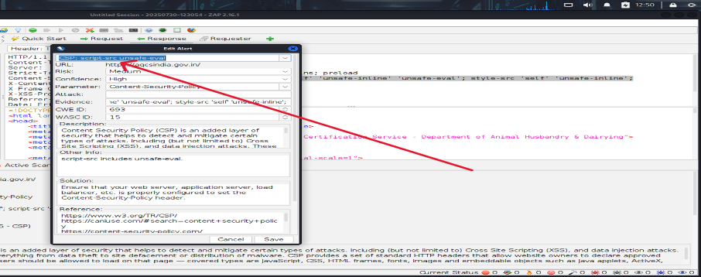

**After: -**

**Retest Result:-**

**1. Browser Console Test:**

**eval("alert('XSS Test')");**

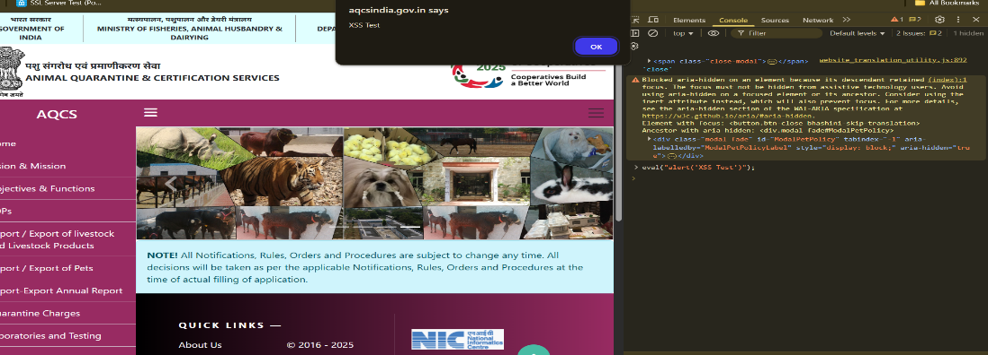

**Now:-**

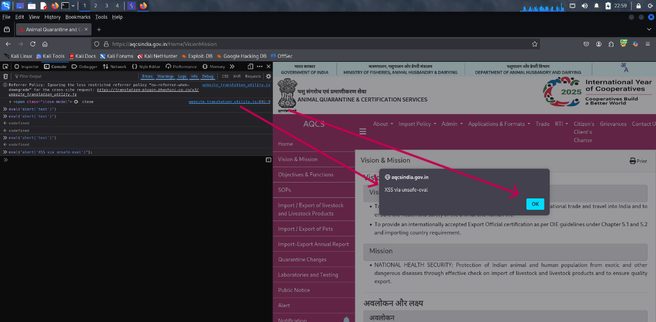

**Recommendations:**

**Ensure that your web server, application server, load balancer, etc. is properly configured to set the Content-Security-Policy header.**

**Tool Used:-** OWASP ZAP, Browser

**Status:** Unpatched still

# CSP: script-src unsafe-inline

|  |  |  |  |
| --- | --- | --- | --- |
| *Brief Description* | *Risk Rating* | *Impact on Application* | *Probability of Attack* |
| *Content Security Policy (CSP) is an added layer of security that helps to detect and mitigate certain types of attacks. Including (but not limited to) Cross Site Scripting (XSS), and data injection attacks. These attacks are used for everything from data theft to site defacement or distribution of malware. CSP provides a set of standard HTTP headers that allow website owners to declare approved sources of content that browsers should be allowed to load on that page — covered types are JavaScript, CSS, HTML frames, fonts, images and embeddable objects such as Java applets, ActiveX, audio and video files.* | *Medium* | *High* | *Medium* |

**Impact:**

**Affected items**

<https://aqcsindia.gov.in/>

**Proof of Concept:**

**Before:-**

**default-src 'self'; script-src 'self' 'unsafe-inline' 'unsafe-eval'; style-src 'self' 'unsafe-inline';**

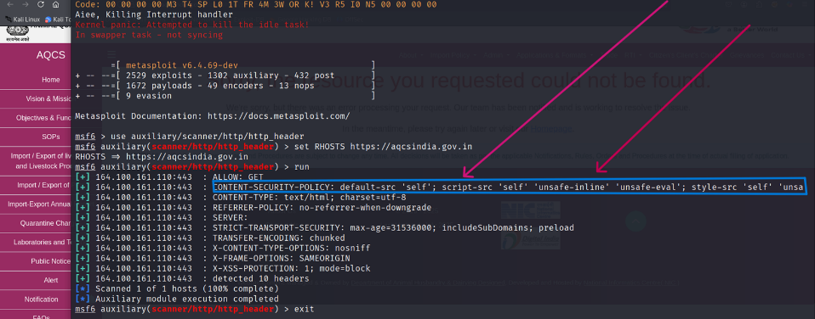

**After:-**

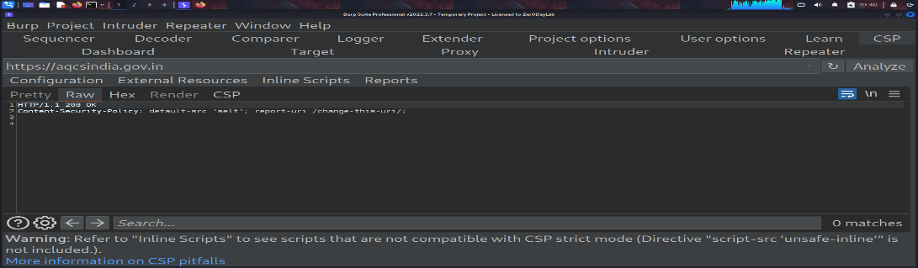

**Now:-**

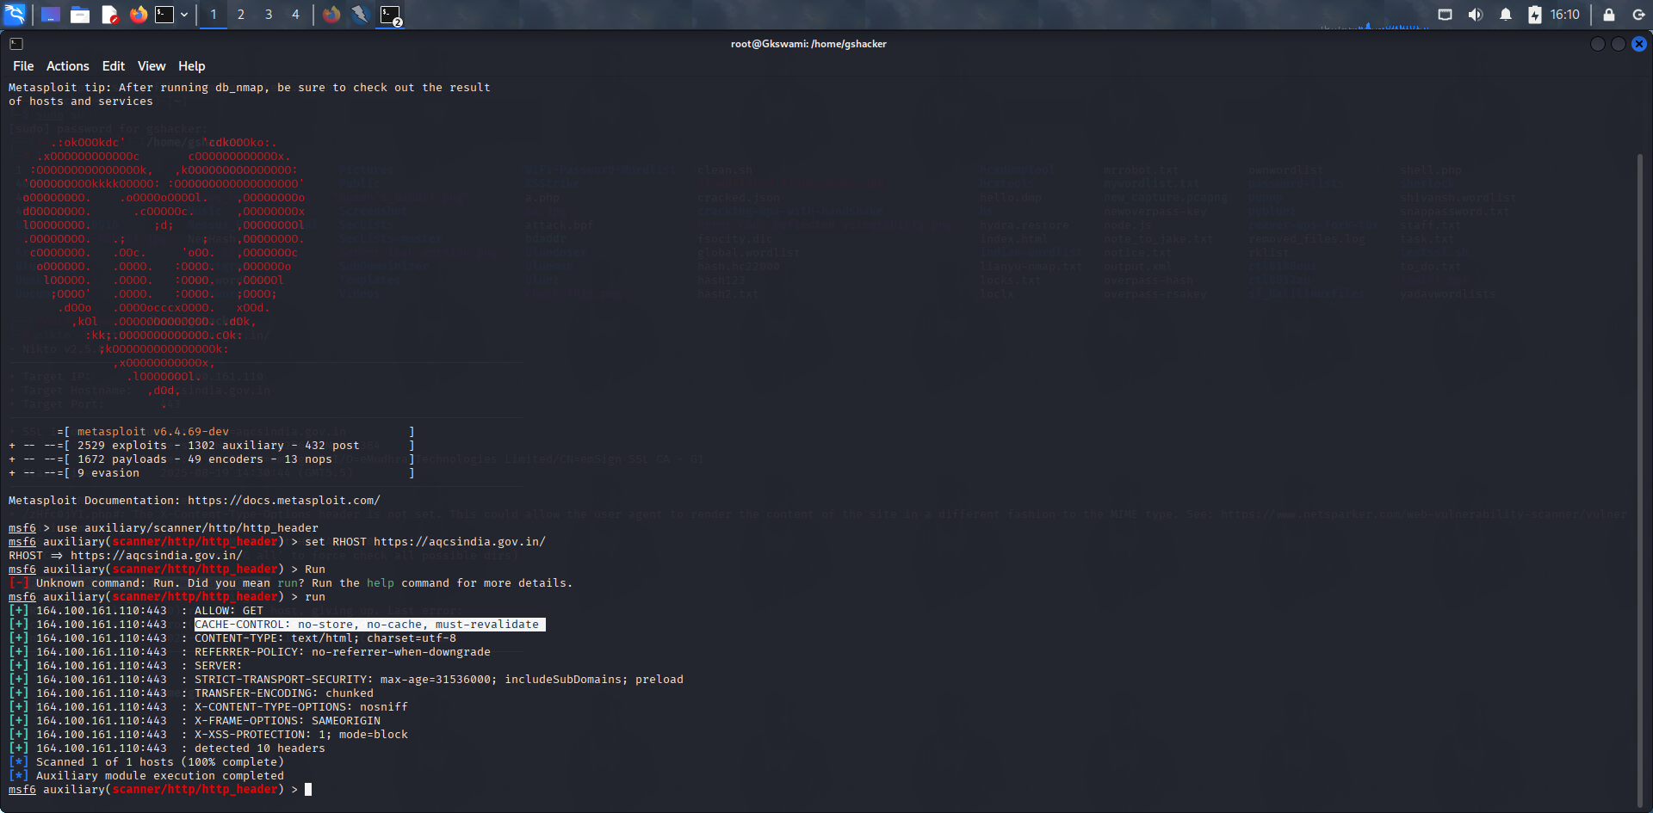

**Recommendations:**

Ensure that your web server, application server, load balancer, etc. is properly configured to set the Content-Security-Policy header.

**Tool Used: -** **Metasploit Framework**

**Status:- Patched**

# CSP: style-src unsafe-inline

|  |  |  |  |
| --- | --- | --- | --- |
| *Brief Description* | *Risk Rating* | *Impact on Application* | *Probability of Attack* |
| Content Security Policy (CSP) is an added layer of security that helps to detect and mitigate certain types of attacks. Including (but not limited to) Cross Site Scripting (XSS), and data injection attacks. These attacks are used for everything from data theft to site defacement or distribution of malware. CSP provides a set of standard HTTP headers that allow website owners to declare approved sources of content that browsers should be allowed to load on that page — covered types are JavaScript, CSS, HTML frames, fonts, images and embeddable objects such as Java applets, ActiveX, audio and video files. | *Medium* | *Medium* | High |

**Impact:**

**-** Using style-src 'unsafe-inline' in CSP allows inline CSS to execute, which can enable style-based injection attacks. Attackers may abuse this to perform UI redress or data exfiltration via malicious styles. It reduces the effectiveness of CSP in preventing content injection

**Affected items**

<https://aqcsindia.gov.in/>

**Proof of Concept:**

**Befor:-**

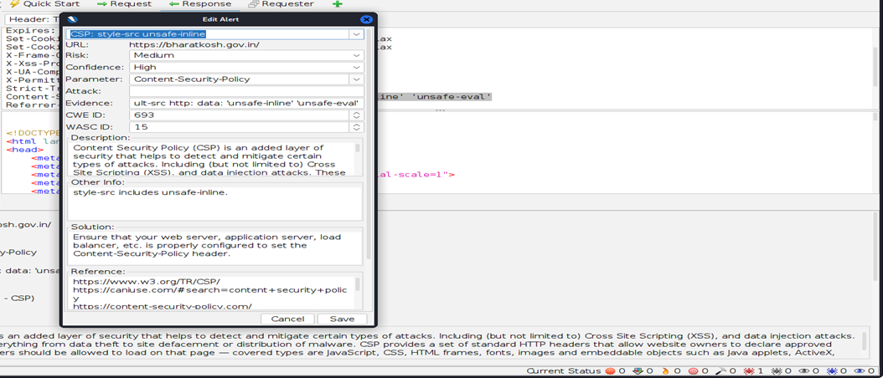

**After:-**

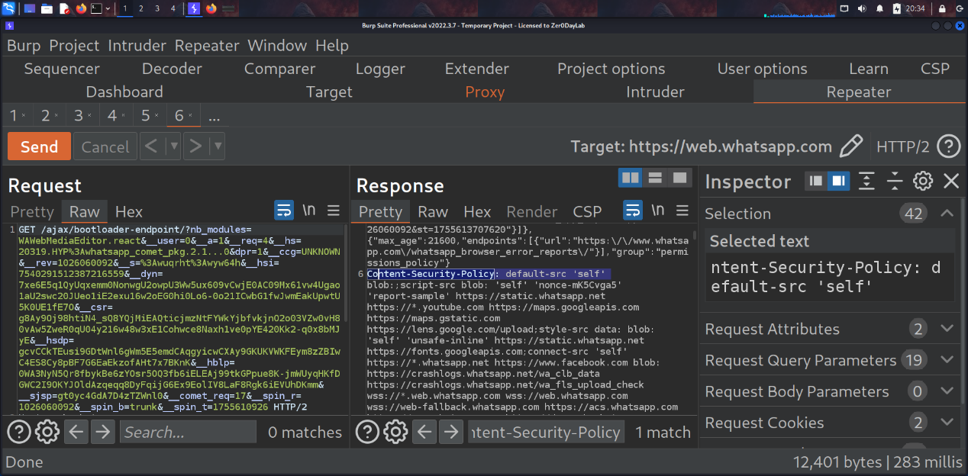

**Now:-**

**Step 1 website open in browser**

**Step 2 Press F12**

**Step 3 Open Browser console**

**Step 4 write script code**

**[var el = document.createElement("div");**

**el.setAttribute("style","position:fixed;top:0;left:0;width:100%;height:100%;background:black;z-index:9999;");**

**document.body.appendChild(el);]**

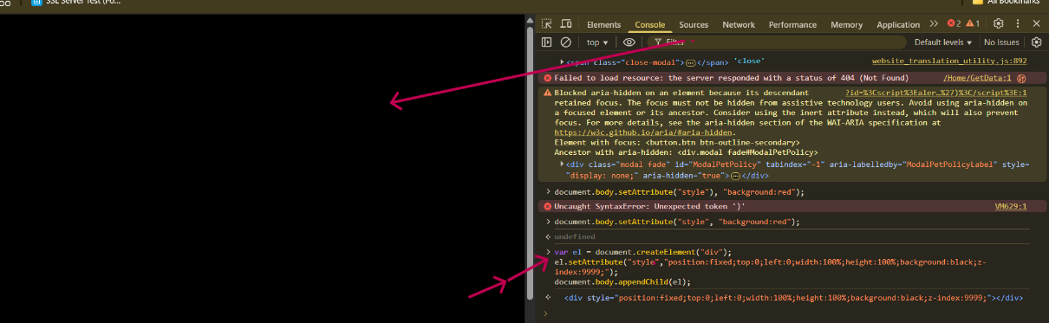

**Recommendations:**

Ensure that your web server, application server, load balancer, etc. is properly configured to set the Content-Security-Policy header.

Tool Used: - **Owasp Zap, Burpsuite**

**Status:- Unpatched**

# Server Leaks Version Information via "Server" HTTP Response Header Field

|  |  |  |  |
| --- | --- | --- | --- |
| ***Brief Description*** | ***Risk Rating*** | ***Impact on Application*** | ***Probability of Attack*** |
| **The web/application server is leaking version information via the "Server" HTTP**  **response header. Access to such information may facilitate attackers identifying other vulnerabilities your web/application server is subject to.** | Low | Low | High |

**Impact:**

**Disclosure of server version information helps attackers identify the underlying technology stack and exact version in use. This information can be leveraged during reconnaissance to find and exploit known vulnerabilities, increasing the risk of targeted attacks against the application and infrastructure.**

**Affected items**

[**https://tracking-protection.cdn.mozilla.net/content-track-digest256/128.0/1732308867**](https://tracking-protection.cdn.mozilla.net/content-track-digest256/128.0/1732308867)

**Proof of Concept:**

**Before: -**

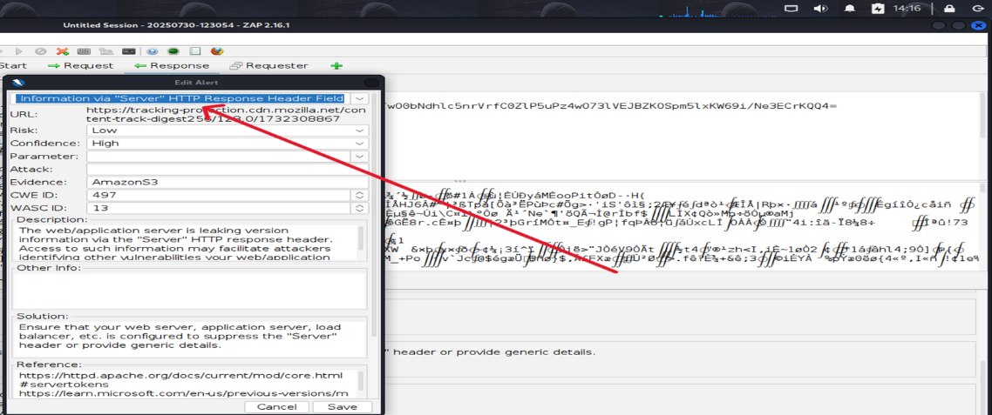

**After:-**

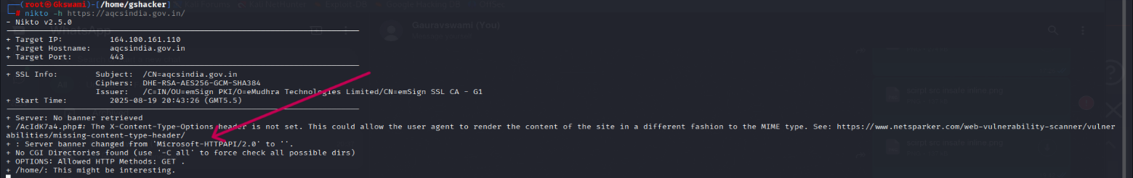

**Now:-**

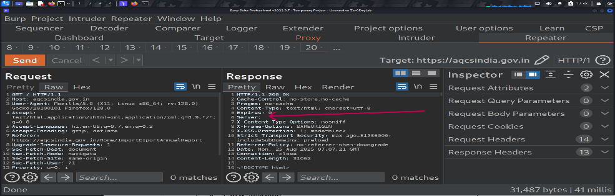

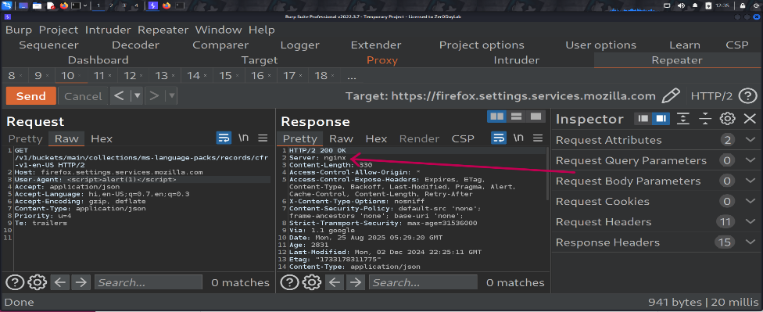

**Recommendations:**

**Ensure that your web server, application server, load balancer, etc. is configured to suppress the "Server" header or provide generic details.**

**Tool Used: -** **Owasp Zap**

**Status:- Patched**

# Strict-Transport-Security Header Not Set

|  |  |  |  |
| --- | --- | --- | --- |
| ***Brief Description*** | ***Risk Rating*** | ***Impact on Application*** | ***Probability of Attack*** |
| HTTP Strict Transport Security (HSTS) is a web security policy mechanism whereby a web server declares that complying user agents (such as a web browser) are to interact with it using only secure HTTPS connections (i.e. HTTP layered over TLS/SSL). HSTS is an IETF standards track protocol and is specified in RFC 6797 | Low | Medium | Medium |

**Impact:**

Absence of the Strict-Transport-Security (HSTS) header allows attackers to perform SSL stripping attacks by forcing users to access the site over HTTP. This can lead to sensitive data being transmitted in cleartext. Without HSTS, users are not forcibly redirected to secure HTTPS connections.

**Affected items**

<https://tracking-protection.cdn.mozilla.net/content-track-digest256/128.0/1732308867>

**Proof of Concept:**

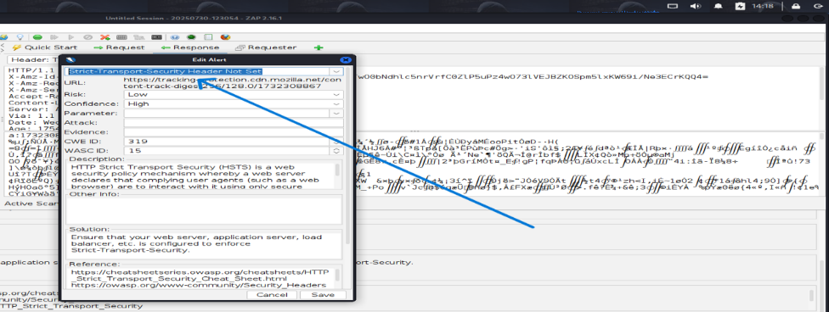

**After:-**

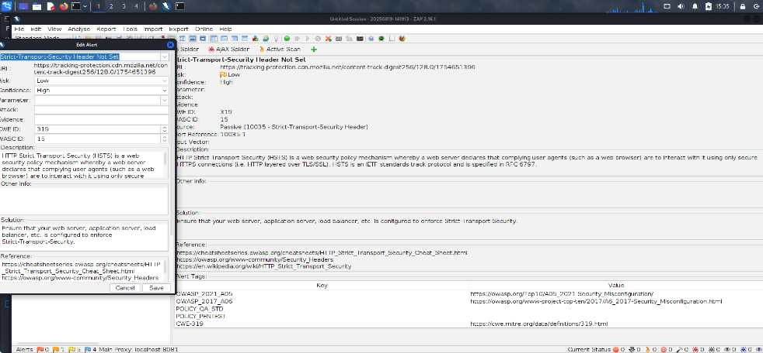

**Now:-**

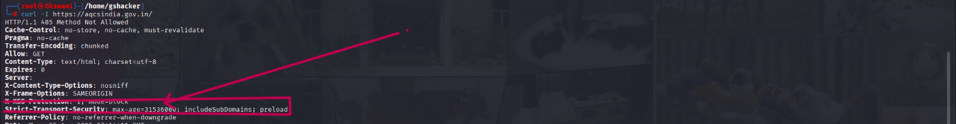

**Recommendations:**

Ensure that your web server, application server, load balancer, etc. is configured to enforce Strict-Transport-Security.

**Tool Used: -** OWASP ZAP

Status:- Patched

# Timestamp Disclosure - Unix

|  |  |  |  |
| --- | --- | --- | --- |
| ***Brief Description*** | ***Risk Rating*** | ***Impact on Application*** | ***Probability of Attack*** |
| A timestamp was disclosed by the application/web server. – Unix | Low | Medium | Medium |

**Impact:**

Unix timestamp disclosure can reveal system or file generation times, which may help attackers estimate software deployment dates or session validity. This information can aid in targeted attacks like session prediction or version-based exploitation. Though low risk, it can support other vulnerabilities.

**Affected items:**

[**https://aqcsindia.gov.in/pdfs/gem-contract.pdf**](https://aqcsindia.gov.in/pdfs/gem-contract.pdf)

**Proof of Concept:**

**Before:-**

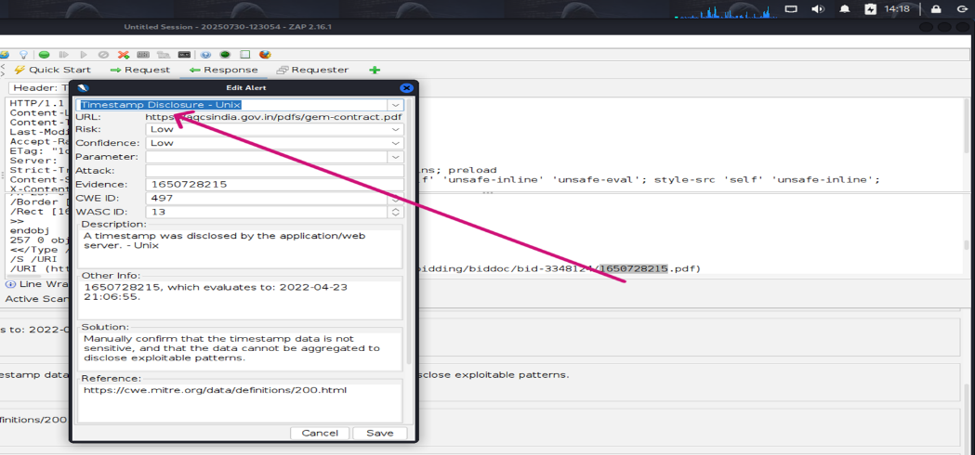

**After:-**

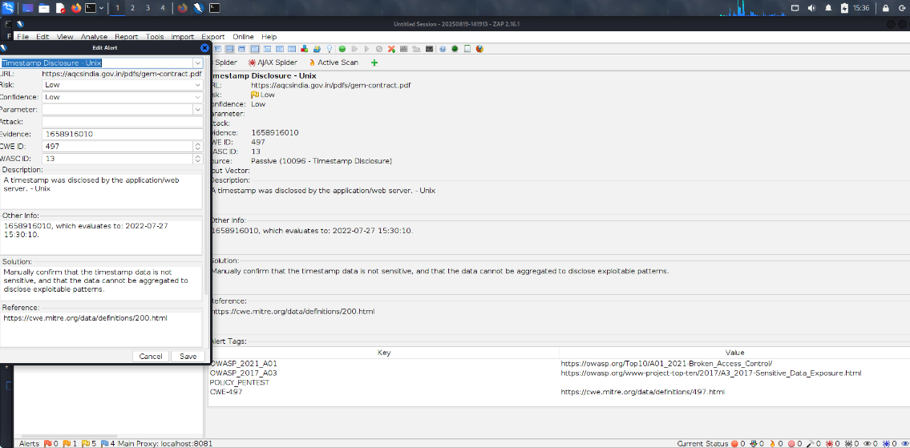

**Now:-**

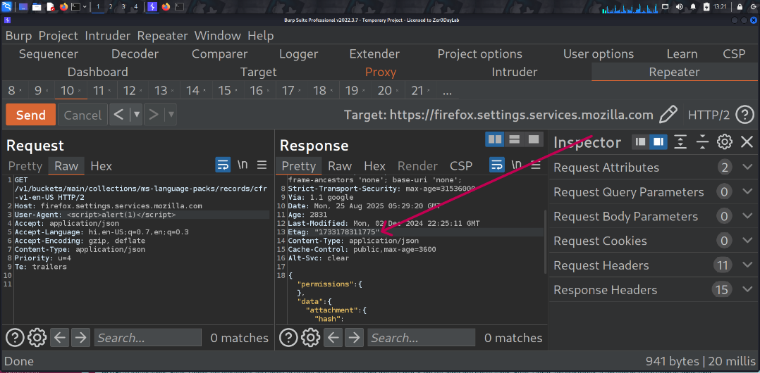

**Recommendations:**

Manually confirm that the timestamp data is not sensitive, and that the data cannot be aggregated to

disclose exploitable patterns.

**Tool Used: -** OWASP ZAP

Status:- Still Unpatched

# X-Content-Type-Options Header Missing

|  |  |  |  |
| --- | --- | --- | --- |
| ***Brief Description*** | ***Risk Rating*** | ***Impact on Application*** | ***Probability of Attack*** |
| The X-Content-Type-Options header is not set in the server response. Without this header, browsers may perform MIME type sniffing and interpret files as a different content type than what is declared, which can potentially expose the application to security risks. | Low | Low | High |

**Impact:**

An attacker may exploit this behavior by tricking the browser into executing malicious scripts

or delivering harmful content disguised under a safe MIME type. This could lead to Cross-Site

Scripting (XSS), malware execution, or other client-side attacks.

**Affected items:**

[**https://tracking-protection.cdn.mozilla.net/content-track-digest256/128.0/1732308867**](https://tracking-protection.cdn.mozilla.net/content-track-digest256/128.0/1732308867)

**Proof of Concept:**

**Before:-**

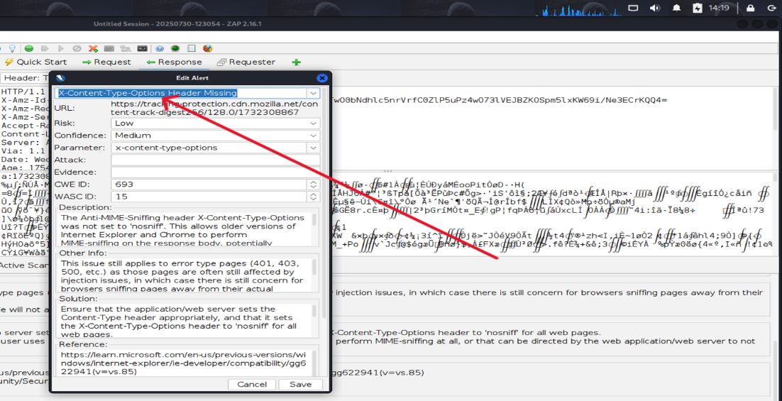

After:-

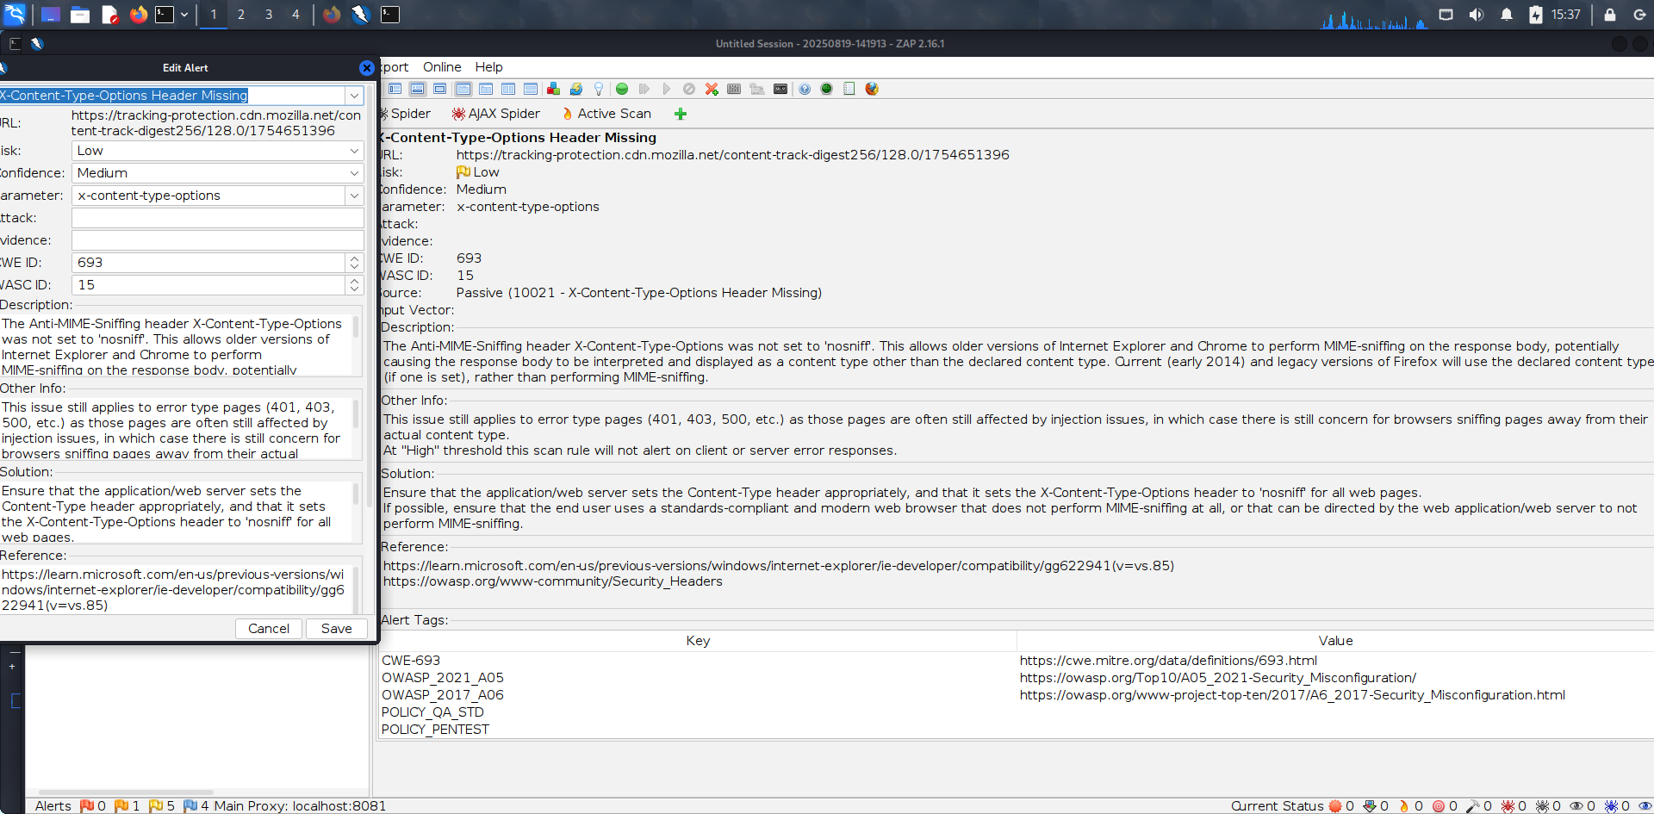

**Now:-**

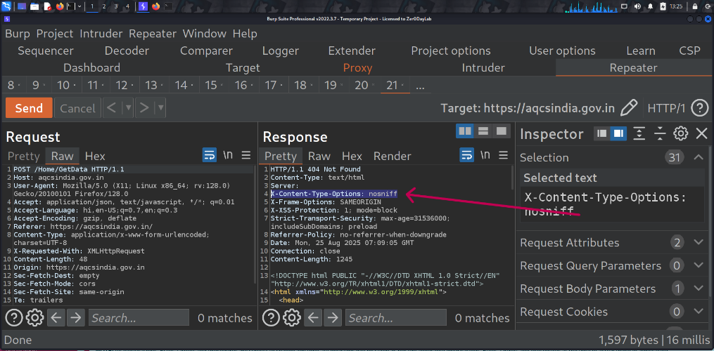

**Recommendations:**

Configure the server to include the X-Content-Type-Options header with the value nosniff

in all HTTP responses. This ensures that browsers strictly follow the declared MIME type

and prevents content-type based attacks.

**Tool Used: -** OWASP ZAP

**Status:- Patched**

# Information Disclosure - Suspicious Comment

|  |  |  |  |
| --- | --- | --- | --- |
| ***Brief Description*** | ***Risk Rating*** | ***Impact on Application*** | ***Probability of Attack*** |
| The response appears to contain suspicious comments which may help an attacker. | Informational | Low | Low |

**Impact:**

Shows your authentication endpoints are properly detectable (good for automated testing)

- Confirms ZAP is correctly identifying your auth flow for potential future tests

**Affected items**

[**https://aqcsindia.gov.in/js/sweetalert/sweetalert-dev**](https://aqcsindia.gov.in/js/sweetalert/sweetalert-dev)**.**

**Proof of Concept:**

**Before:-**

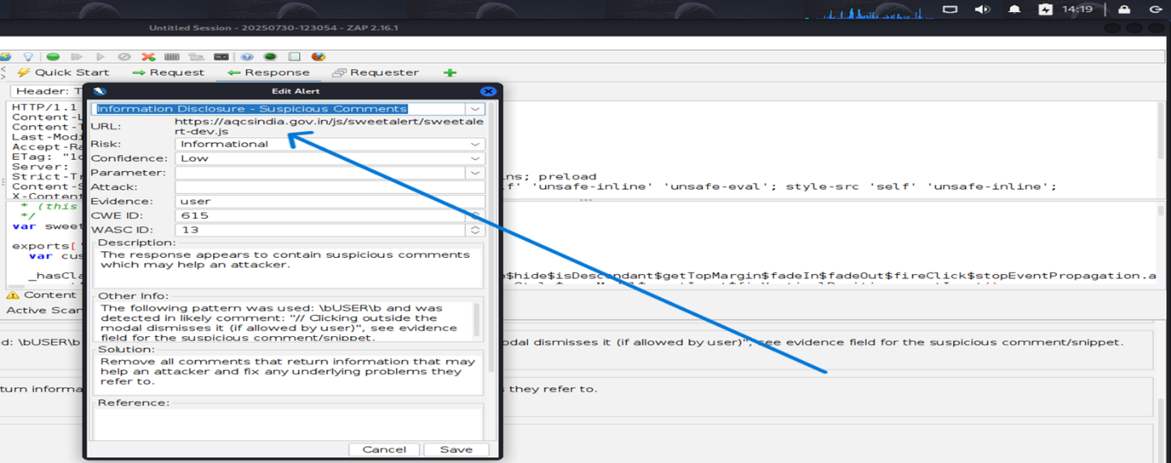

**After:-**

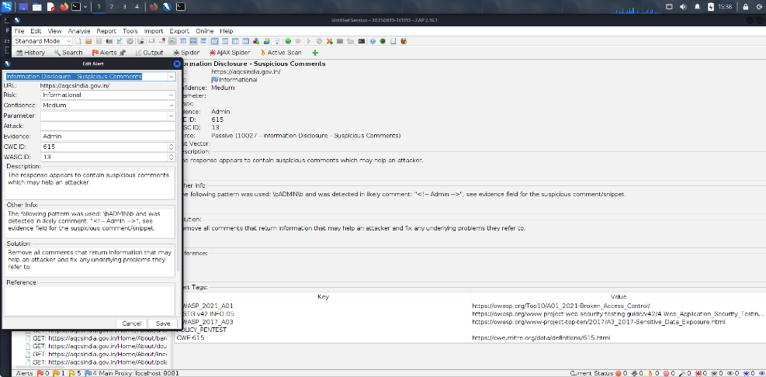

**Now:-**

**Recommendations:**

Remove all comments that return information that may help an attacker and fix any underlying problems they refer to.

**Tool Used: -** Owasp Zap

**Status:- Patched**

# Modern Web Application

|  |  |  |  |
| --- | --- | --- | --- |
| ***Brief Description*** | ***Risk Rating*** | ***Impact on Application*** | ***Probability of Attack*** |
| The application appears to be a modern web application. If you need to explore it automatically then the  Ajax Spider may well be more effective than the standard one. | Informational | Low | Low |

**Impact:**

Modern web applications often rely heavily on complex client-side code (JavaScript

frameworks, APIs, and third-party libraries). If not securely implemented, this increases the

attack surface, potentially leading to issues like XSS, insecure API calls, dependency

vulnerabilities, and sensitive data exposure through the client side.

**Affected items**

**[https://aqcsindia.gov.in](https://bharatkosh.gov.in/)**

**Proof of Concept:**

**Before:-**

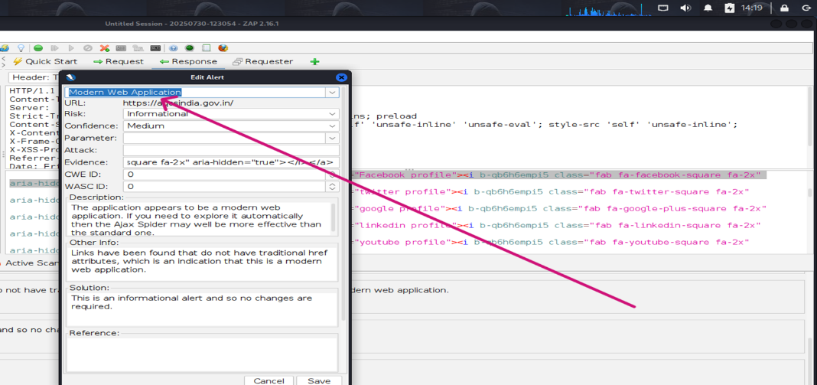

**After:-**

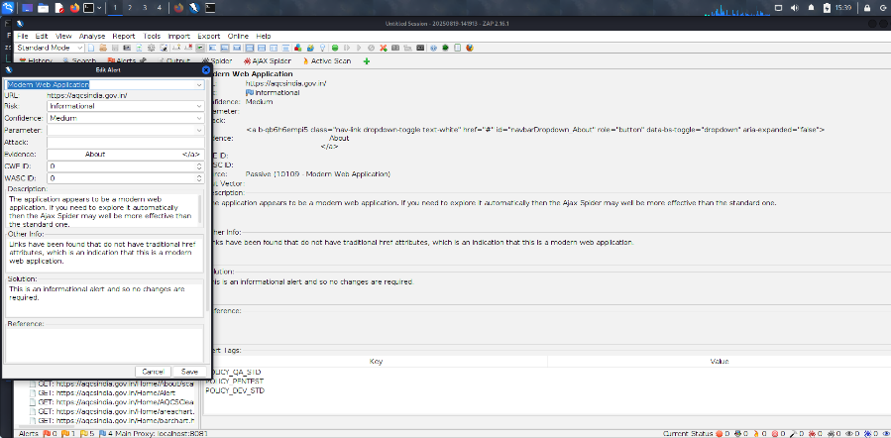

**Recommendations:**

This is an informational alert and so no changes are required.

**Tool Used: -** OWASP ZAP

# Re-examine Cache-control Directives

|  |  |  |  |
| --- | --- | --- | --- |
| ***Brief Description*** | ***Risk Rating*** | ***Impact on Application*** | ***Probability of Attack*** |
| The cache-control header has not been set properly or is missing, allowing the browser and proxies to cache content. For static assets like css, js, or image files this might be intended,  however, the resources should be reviewed to ensure that no sensitive content will be cached. | Informational | Low | Low |

**Impact:**

Improper or missing Cache-Control directives may allow sensitive data (such as session

tokens, personal information, or financial details) to be cached on shared browsers, proxies,

or intermediate servers. This can result in unauthorized data exposure to other users and

increase the risk of information disclosure.

**Affected items**

<https://aqcsindia.gov.in/>

**Proof of Concept:**

**Before:-**

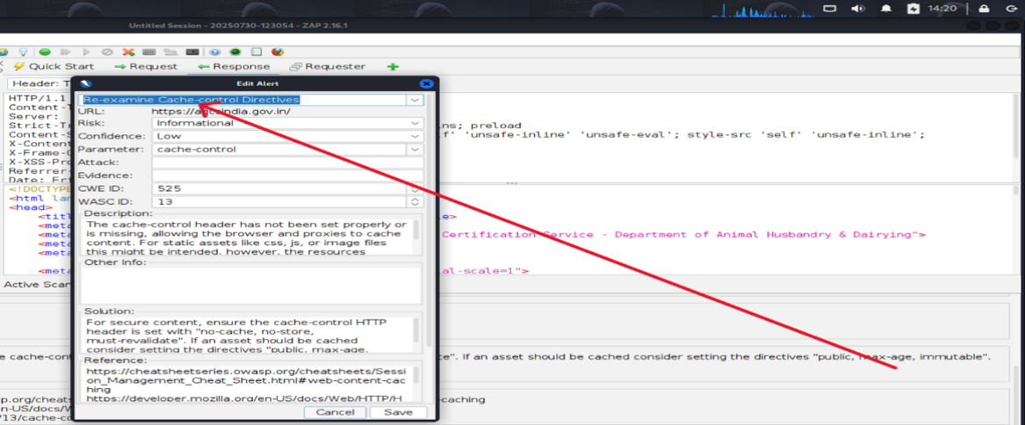

**After:-**

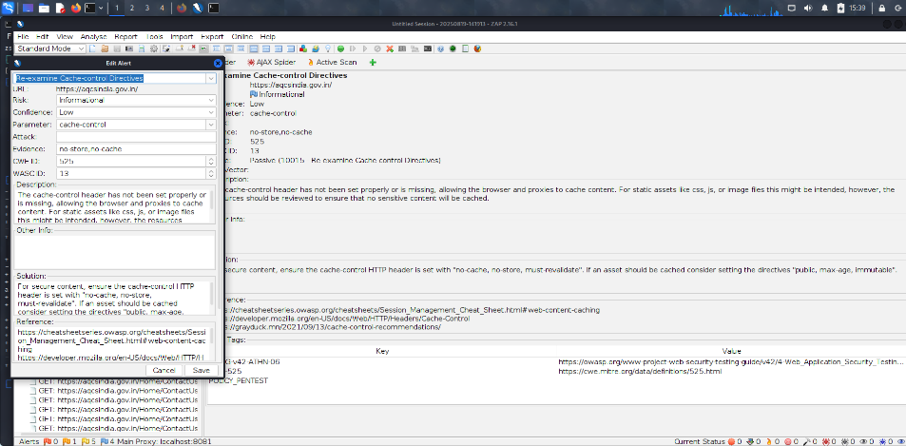

**Now:-**

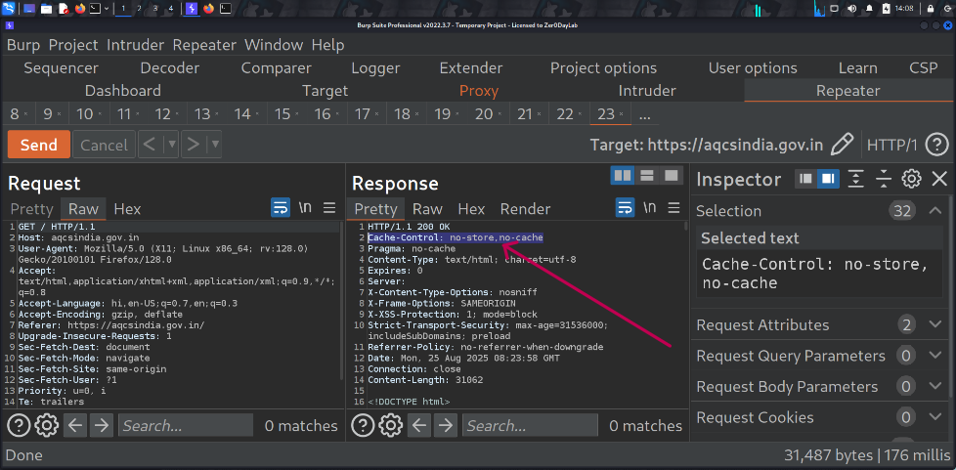

**Recommendations:**

For secure content, ensure the cache-control HTTP header is set with "no-cache, no-store,

must-revalidate". If an asset should be cached consider setting the directives "public, max-age, immutable.

**Tool Used: -** OWASP ZAP

**Status:- Patched**

14. General Guidelines

**Validate Input and Output**

The input that the server receives from the user can lead to malicious code entering the server. Similarly, the output shown to the user can transmit malicious code to the client system. All user input and output should be checked to ensure it is both appropriate and expected. Input validation should be done on the client-side as well as on the server-side.

There are three main models to consider about when designing a data validation strategy.

**Accept Only Known Valid Data**

A character set may be defined for each field where input from the user is accepted. E.g. “A-Z, a-z, @,., 0-9, _” is a character set for a field that accepts user email.

Reject Known Bad Data

A character set of bad data may be defined for the site that has to be rejected. E.g. “CREATE, DROP, OR”

**Sanitize Known Bad Data**

A character set of bad data is defined and any input field that has such a character is modified. E.g. “If there is a single quote (‘) in the data, it is replaced with two single quotes.”

All methods must check:

* Data Type
* Syntax
* Length

It is recommended to use the strategy of “Accept only known data”. Further all the allowed input/output data must be sanitized on the server side by replacing scripts tags, sent as part of user input/output, with appropriate representations.

For example

* “<” by &lt;
* “>” by &gt;
* “(“ by &#40

This would avoid scripts from being executed on the client side.

Client-side input must also be checked for URL encoded data. URL encoding sometimes referred to as percent encoding, is the accepted method of representing characters within a URI that may need special syntax handling to be correctly interpreted. This is achieved by encoding the character to be interpreted with a sequence of three characters. This triplet sequence consists of the percentage character “%” followed by the two hexadecimal digits representing the octet code of the original character. For example, the US-ASCII character set represents a space with octet code 32, or hexadecimal 20. Thus, its URL-encoded representation is %20.

Other common characters that can be used for malicious purposes and their URL encoded representations are: -

|  |  |  |
| --- | --- | --- |
| **#** | **Character** | **URL encoded** |
|  | ‘ | %27 |
|  | “ | %22 |
|  | ; | %3b |
|  | < | %3c |
|  | = | %3d |
|  | > | %3e |
|  | ) | %29 |
|  | ( | %28 |
|  | space | %20 |

All input validation checks should be completed after the data has been decoded and validated as acceptable content (e.g. maximum and minimum lengths, correct data type, does not contain any encoded data, textual data only contains the characters a-z and A-Z etc.)

A one-time check on the database is to be made for invalid malicious data. This would enable removal of input that has not been validated in earlier sessions. As otherwise the invalid data may cause script execution on the user’s browser.

**Session Management / Strong session tracking**

**Session Tokens on Logout**

In shared computing environments, session tokens take on a new risk. If the session tokens are not invalidated after logout, they can be reused to gain access to the application. It is imperative for the application to remove the cookies from both the server and the client side after the user has logged out. The user session maintained on the server side must also be invalidated immediately after logout.

**Session Time-out**

All the user Session tokens must be timed-out after a certain interval of user inactivity. The Session tokens that do not expire on the HTTP server can allow an attacker unlimited time to guess or brute force a valid authenticated session token. If a user's cookie file is captured or brute-forced, then an attacker can use these static-session tokens to gain access to that user's web accounts. Additionally, session tokens can be potentially logged and cached in proxy servers that, if broken into by an attacker, may contain similar sorts of information in logs that can be exploited if the particular session has not been expired on the HTTP server.

**Session Token Transmission**

If a session token is captured in transit through network interception, a web application account is then trivially prone to a replay or hijacking attack. Typical web encryption technologies include Secure Sockets Layer (SSLv2/v3) and Transport Layer Security (TLS v1) protocols in order to safeguard the state mechanism token.

Some more key points to remember:

Session ID’s that are used should have the following properties:

1. Randomness.
   1. Session Ids must be randomly generated.
   2. Session Ids must be unpredictable.
   3. Make use of non-linear algorithms to generate session ID’s
2. Session ID Size
   1. The size of a session ID should be large enough to ensure that it is not vulnerable to a brute force attack.
   2. The character set used should be complex. i.e. Make use of special characters.
   3. A length of 50 random characters is advised.

**Salted Hashing**

What is salted hashing?

The process starts with 2 elements of data:

1.) A clear text string (this could represent a password for instance).

2.) The salt, a random seed of data. This is the value used to augment a hash in order to ensure that 2 hashes of identical data yield different output.

In pseudo code we generate a salted hash as follows:

1.) Get the source string and salt as separate binary objects

2.) Concatenate the 2 binary values

3.) SHA hash the concatenation into Salted Password Hash

4.) Base64 Encode (concat (Salted Password Hash, Salt))

Credentials should be encrypted using salted hashes, so that even if the hashes are sniffed the possibility of replay attack does not exist.

References**: http://www.owasp.org/images/3/33/Salted_Hashes_Demystified.doc**

**Cache Control Directives**

Pages that contain sensitive information should not be stored in the local cache of the browser. To enforce this, HTTP directives need to be specified in the response. These HTTP directives need to be used to prevent enlisting of links on the browser history. The following HTTP directives can be sent by the server along with the response to the client. This would direct the browser to send a new request to the server each time it is generated.

**Expires: <a previous date>, for e.g. Expires: Thu, 10 Jan 2020 19:20:00 GMT**

**Cache-Control: private**

* ***Cache-Control: no-cache***
* ***Cache-Control: no-store***
* ***Cache-Control: must-revalidate***
* ***Pragma: no-cache***

The directive “Cache-Control: must-revalidate” directs the browser to fetch the pages from the server rather than picking it up from the local “Temporary Internet Folders”. It also directs the browser to remove the file from the temporary folders.